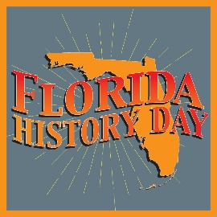
2023–24 Florida History Day
“Turning Points in History”

Teacher of Merit Award

Award Criteria
To be eligible for the Teacher of Merit Award, a teacher must be a Florida History Day participant with at least three years of experience. The winner will receive a $500 prize sponsored by Florida Council for History Education (FLCHE).

Interested educators must submit an application form, a narrative about how they fulfill the criteria below (1–3 pages), a personal resume (1–2 pages), and three letters of support by individuals who can give examples of excellence in history teaching.

Evaluation criteria for the state and national awards are presented below.

1. Development and use of creative teaching methods that interest students in history and help them to make exciting discoveries about the past.

Examples include:
- active learning projects within and outside the classroom, such as mock debates between historical characters or oral history projects within the community;
- innovative use of primary historical source material in the classroom;
- use of communication technology in history research and classroom learning;
- practice of teaching methods that link history to students' broader interests—for example, through interdisciplinary approaches to history topics or the development of projects that link history to current events and debates; and
- use of teaching methods that build a range of skills in students as they study history.

2. Exemplary commitment to helping students develop their interest in history and recognizing their achievements.

Examples include:
- exemplary support and guidance for students working on History Day projects;
- helping students showcase their history projects within the community and/or publish their material;
- overall commitment to the intellectual development of individual students; and
- encouragement of students to use their understanding of history to become engaged, informed citizens in their community and beyond.

Continued
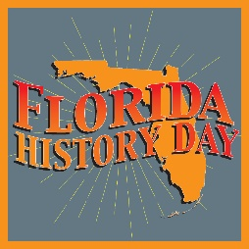
2023–24 Florida History Day
“Turning Points in History”

Teacher of Merit Application

Name __________________________________________________________________________

County _________________________________________________________________________

School name ____________________________________________________________________

School address __________________________________________________________________

Work and home phone _____________________________________________________________

FAX number ____________________________________________________________________

Email __________________________________________________________________________

Grade(s) that you teach ____________________________________________________________

Subject(s) that you teach ___________________________________________________________

How long have you participated in History Day? ________________________________________

Include with this form
- A narrative about how you meet the evaluation criteria (1–3 pages)
- Personal resume (1–2 pages)
- Three letters of support by individuals who can give examples of excellence in history teaching

I verify that the information provided above is correct ___________________________________

- The winner will be announced during the Florida History Day Awards Ceremony on May 7, 2024.

- The recipient will receive a $500 prize.

To be considered, mail or email the nomination materials by March 27, 2024, to:

Florida History Day Coordinator
Museum of Florida History
500 S. Bronough St., Tallahassee, FL 32399–0250
Phone: 850.245.6326
floridahistoryday@dos.myflorida.com

